Finding the best locations for expansion for the Example Franchise in Manhattan and Toronto.

Shawn Lim Junhe

28 May 2020

1. Introduction and Problem

Example Pte Ltd is a Singaporean Franchise looking to expand its operations overseas after a successful launch in Singapore and subsequent expansion into South East Asia. The strategic management of the company has decided on New York City, Manhattan and Toronto, Canada as possible locations to spearhead its expansion into the North American region. However, the team is currently unsure about which city would be most suitable for this expansion. This choice of country is of paramount importance as it sets the tone and perception of the company in the North America Region and is likely to make or break the success of subsequent expansion. Due to the importance of this choice, the company has engaged its data science team to suggest which city and locations would be the most suitable for Example’s entrance into the North America Region. Analysis from previous expansion has shown that locations that are the most similar to Example’s most successful store in Orchard, Singapore tend to also enjoy a high degree of success as well. As such the team has decided to select locations that are the most similar to the Orchard Store.

1. Data Acquisition and Cleaning
   1. Data Sources

Postal codes of the neighborhoods in Toronto was scraped from [Wikipedia](https://en.wikipedia.org/wiki/List_of_postal_codes_of_Canada:_M) and their latitudes and longitudes were obtained using their respective postal codes from [here](http://cocl.us/Geospatial_data). The latitudes and longitudes of the Orchard stall was estimated to the in the vicinity of the Orchard Mass Rapid Transport (MRT) station which was obtained from [here.](https://www.latlong.net/place/orchard-road-singapore-28914.html) The data for Manhattan was obtained from [here.](https://cocl.us/new_york_dataset) By obtaining the latitudes and longitudes of the various neighborhoods, data about venues within their vicinity could then be obtained through the Foursquare API.

* 1. Data Cleaning
     1. Toronto

The data scraped from the Wikipedia page had postal codes that with Boroughs that were “Not assigned” which had to be dropped. The geospatial data could then be merged using the postal codes. Neighborhoods that were outside Toronto was then removed and neighbors with the same postal codes were combined. The geospatial data for the Orchard store was then added to the data set and location information from Foursquare was obtained through the Foursquare API. After the information about the venues for each neighborhood was gathered, they could then be encoded into binary values and grouped so that the frequency of each venue category for each neighborhood could be obtained. The venue categories were then the features on which classification could be performed on. The foursquare data for the orchard store was added to both datasets so that clustering could be done.

* + 1. Manhattan

The cleaning process for the Manhattan data was similar to the Toronto data, except that the latitudes and longitudes for the Manhattan neighborhood were already provided.

* 1. Feature Selection

After data cleaning, there were 1712 samples and 245 features in the Toronto data and 3177 samples and 331 features for the Manhattan data. As the data for the orchard store was included in both datasets, the features of the orchard store was present in both datasets and should not bias the results. None of the features were dropped as the goal of this project was to find out the which neighborhoods were most similar to the orchard store.

1. Exploratory Data Analysis

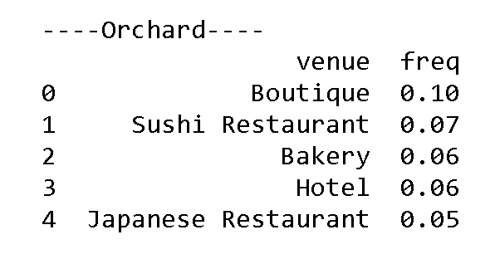

Table 1

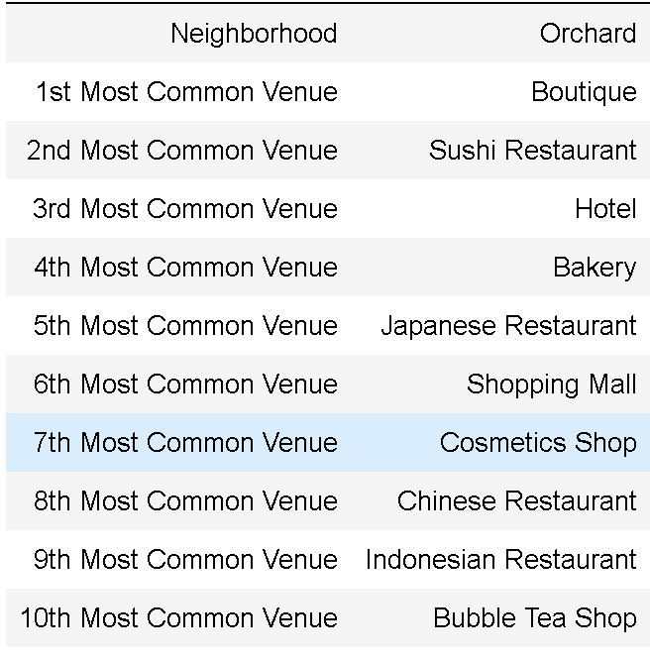

Table 2

The table 1 shows the frequencies of the 5 most common venues within 500 meters of the Orchard store and table 2 shows the top 10 most common venues in descending order. The most common venue category was Boutique stores which might explain the store’s success as it is situated in a higher end part of the city. Further details about the frequencies of the different venues for neighborhoods in the respective cities can be found in the code.

1. Predictive Modeling
   1. Classification models

K – means clustering was chosen to classified the different neighborhoods based on the frequencies of the most common venues. Classification based on the similarity of venues in the different neighborhoods was chosen since as I have mentioned earlier, previous analysis of successful expansions have shown that stores that were similar to the Orchard store had the highest degree of success. The number of neighborhoods in each of the cities were about the same was about the same (around 40) and the number of features for the Toronto neighborhoods was 241 and the number of features for the New York neighborhoods was 331.

* 1. Choosing the optimal k

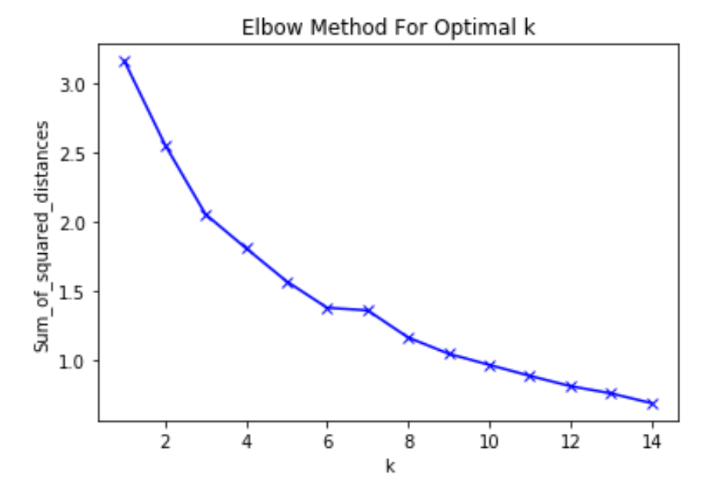

Figure 1: Optimal k for Toronto Dataset

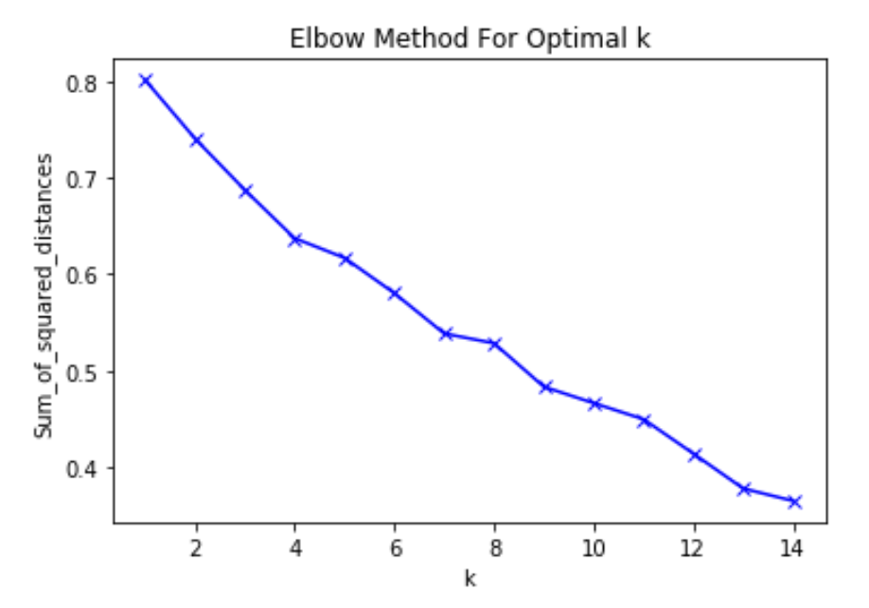

Figure 2: Optimal k for Manhattan Dataset

I chose the optimal k clusters for k-means clustering using the elbow-method for both k-means clustering of the different neighborhoods. Using the method, I found that the optimal k for the Toronto dataset was 6 and the optimal k for the Manhattan dataset was 4. The optimal k for the Manhattan dataset was harder to determine as there was no clear elbow point, so I took the first elbow point which was k equals to 4.

* 1. Results

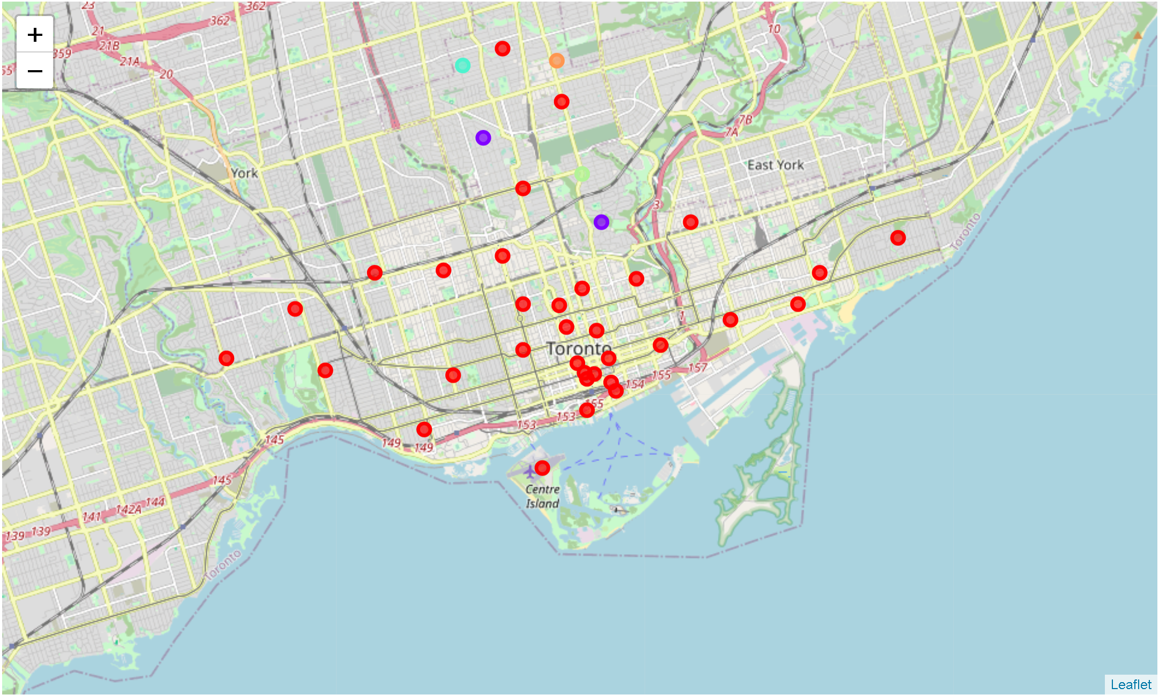

Figure 3: Clustering results for the neighbourhoods of Toronto

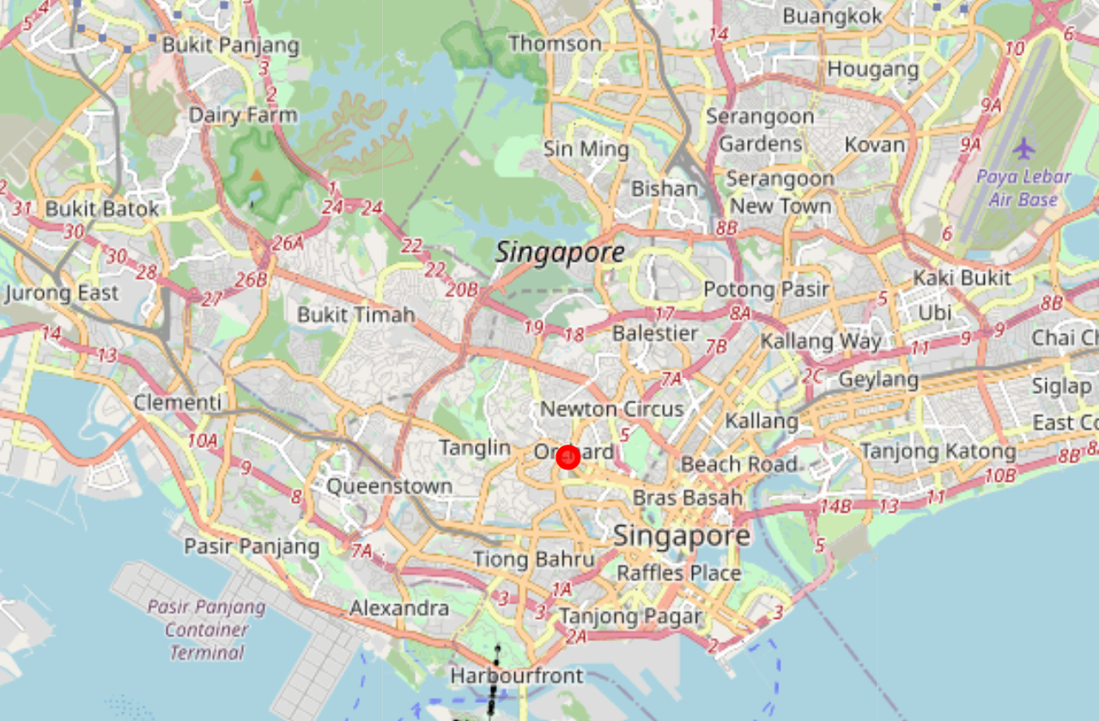

Figure 4: Clustering results for Orchard with the neighbourhoods of Toronto

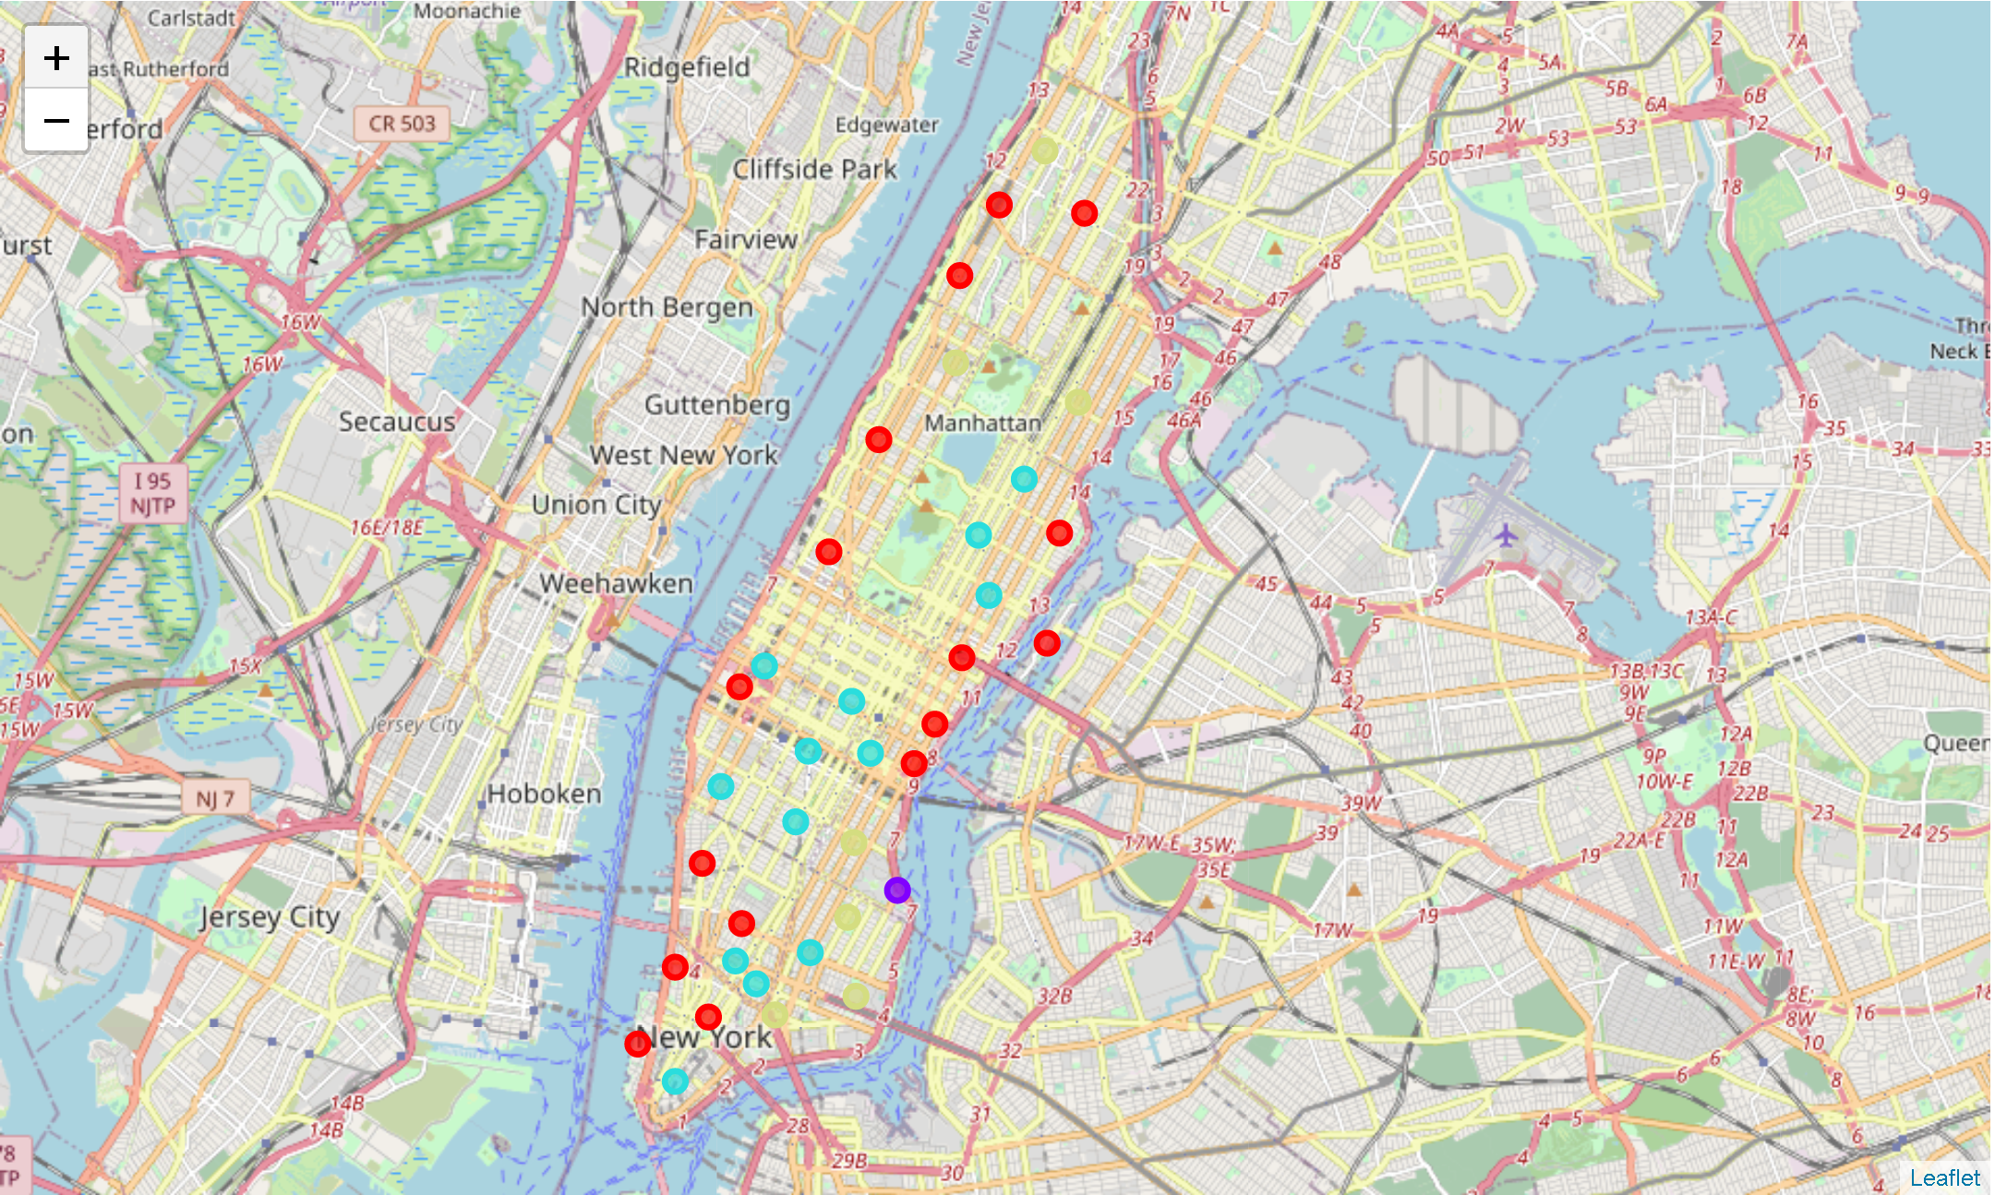

Figure 5: Clustering results for the neighbourhoods of Manhattan

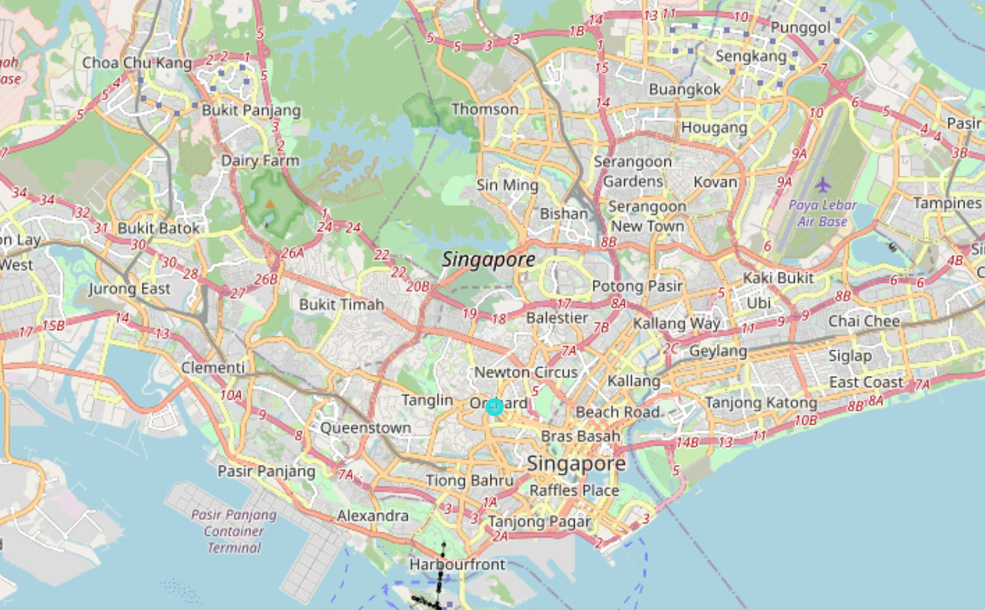

Figure 6: Clustering results for Ochard with the neighbourhoods of Manhattan

The results from the clustering of both the Toronto and Manhattan datasets are shown above in figures 3 – 6. Overall, the Orchard store was clustered with 14 other neighbourhoods in Manhattan and was clustered with 33 other neighbourhoods in Toronto. From this, we can deduce that there would be more opportunities for Example pte ltd for new store locations if it expands to Toronto instead of Manhattan. 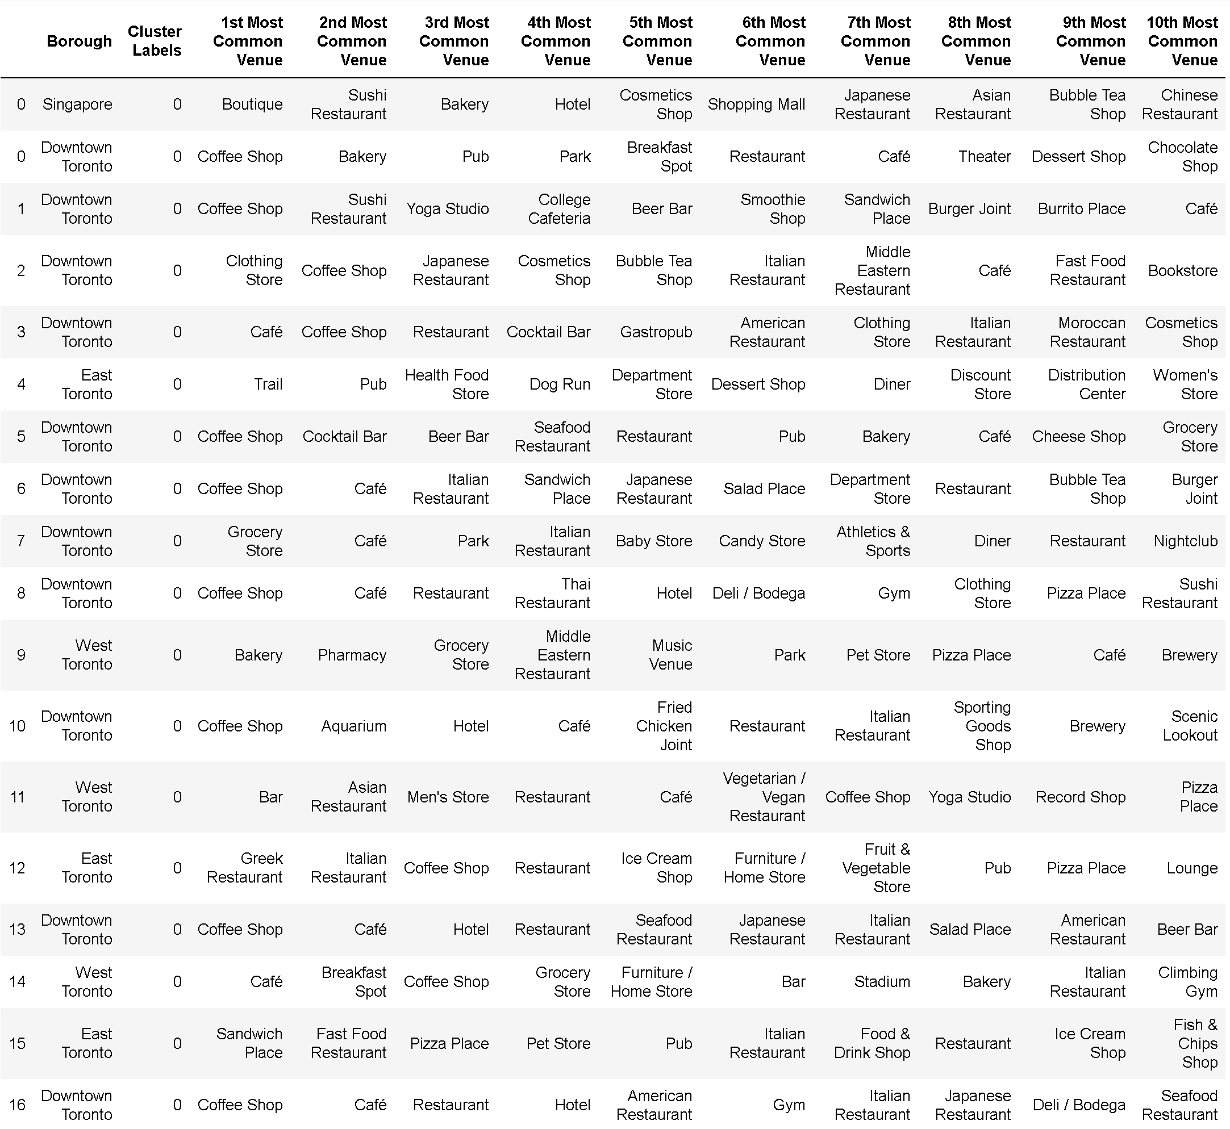

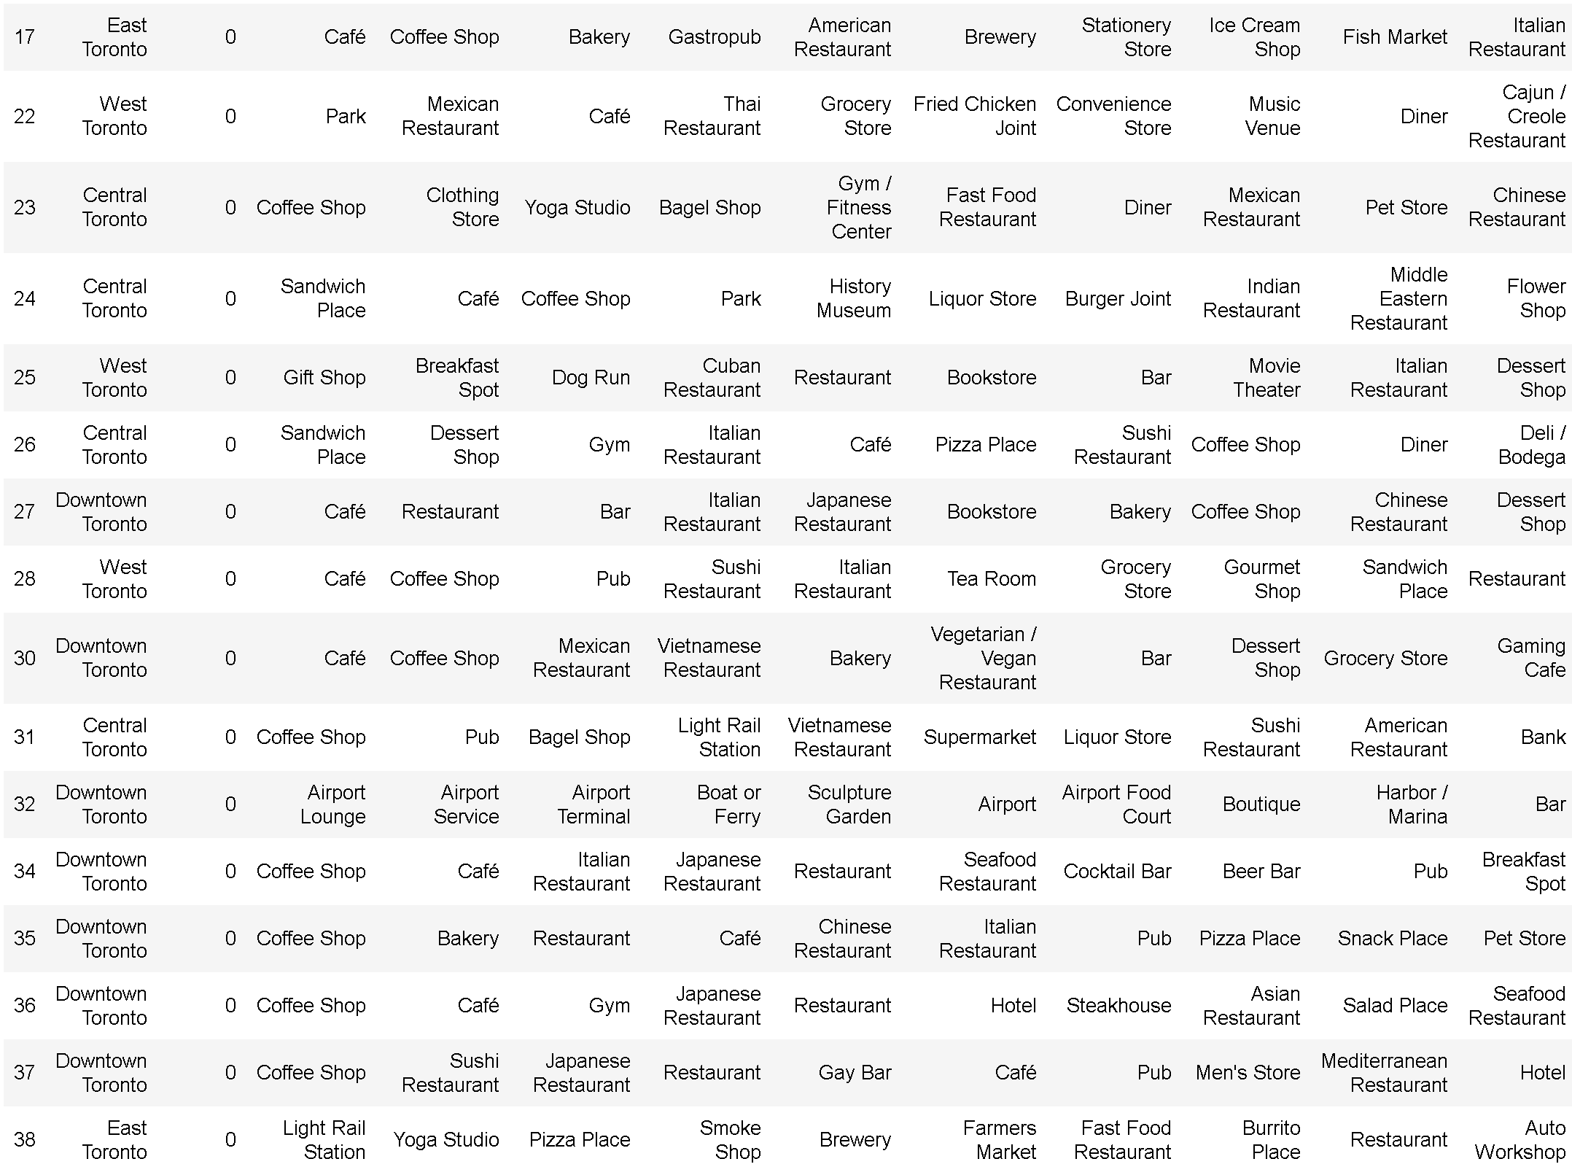

Table 3: Clustering results for the Toronto Neighbourhoods

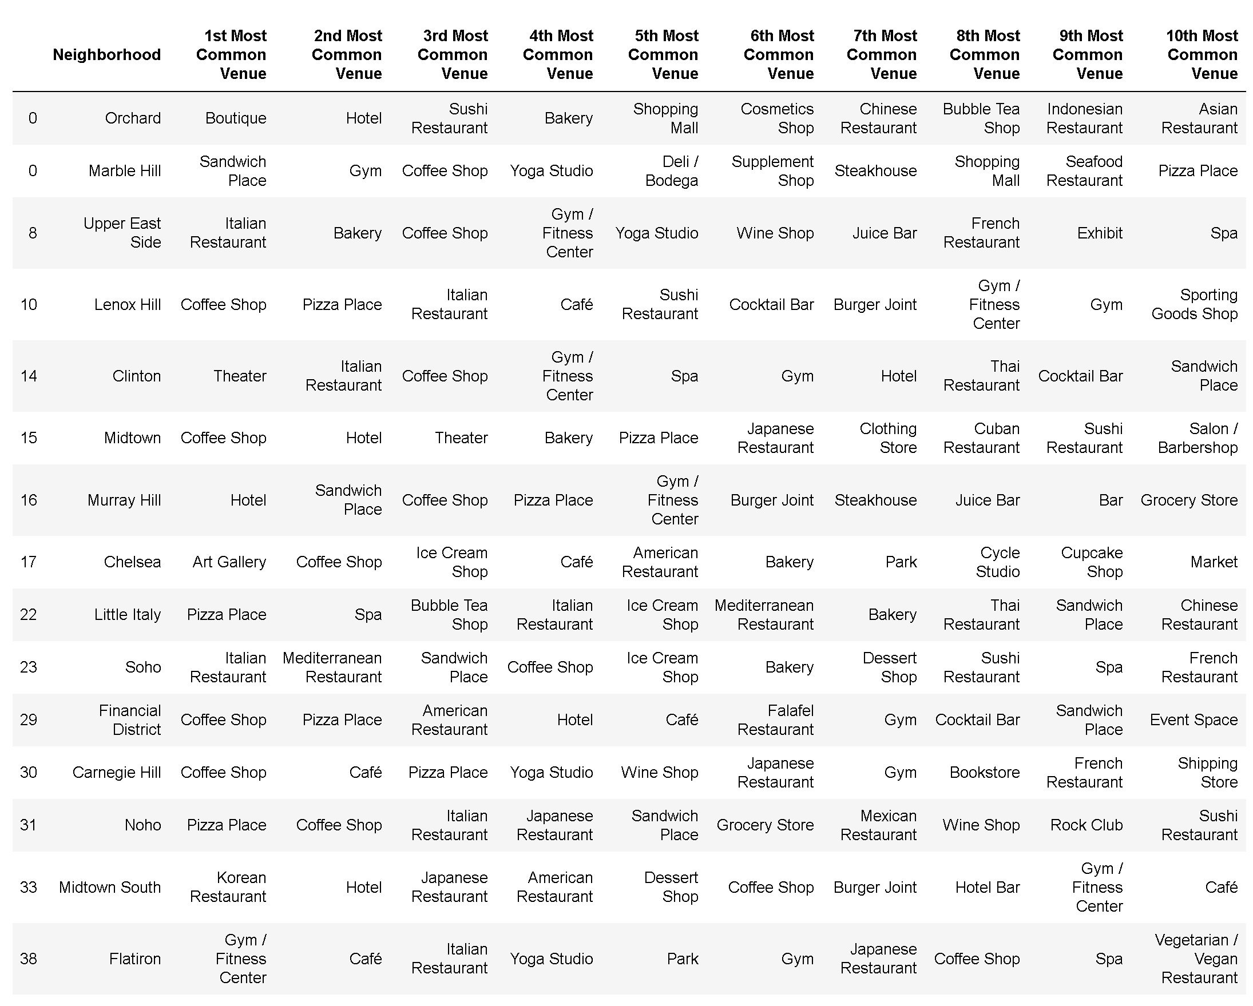

Table 4: Clustering results for Manhattan Neighbourhoods

1. Conclusion

In conclusion, the classification model suggests that Example pte ltd will have more success in its expansion into the North American region if it decides to set up stores in Toronto, Canada instead of Manhattan, New York. However, it should be noted that the Manhattan also remains a promising venue for expansion should Example ptd ltd decide on entering the United States market.